CHAPTER THREE

SYSTEM ANALYSIS AND DESIGN METHODOLOGY

3.1 Chapter Overview
This chapter presents the system analysis, development and design methodology for my phishing website detection project, as well as, a detailed analysis of the current phishing-detection systems. I begin by examining existing anti-phishing measures (user training and technical defenses) and identifying their strengths and weaknesses. I then define the proposed system’s functionality and requirements, and describe its developmental approach. I adopted the Waterfall model as the SDLC methodology – a linear, sequential approach where each phase flows into the next. The Waterfall model “sets distinct endpoints or goals for each phase” and is suitable here because my requirements are well-defined and unlikely to change. In Section 3.2, I analyzed the current versus proposed system, and in Section 3.3, I specified the system requirements and methodology. Section 3.4 outlines the system design with UML and data-flow diagrams to illustrate the architecture. This structured approach ensures that all requirements are clearly documented before implementation.

3.2 System Analysis

3.2.1 Analysis of the Existing System
Current phishing detection tools rely heavily on static methods: for example, web browsers and security software often use blacklists of known malicious URLs or fixed heuristic rules to flag dangerous sites. Additionally, anti-phishing efforts rely on a mix of user education and technical safeguards. These methods provide baseline protection for known threats but have well-known shortcomings. In particular, blacklist-based systems cannot detect previously unseen (“zero-day”) phishing pages, because those URLs are not yet listed. Heuristic or similarity-based detectors (e.g. URL pattern matching) may catch some novel attacks, but they suffer from accuracy and scalability issues. Some commercial solutions use third-party services (like search-engine blacklists), yet these can also fail on new benign or malicious domains. In practice, this means existing systems may miss new attacks or raise false alarms. As one review notes, “Anti-phishing strategies involve educating citizens and technical defense,” and recent work surveys how machine learning methods are being used to identify phishing sites. The analysis thus shows that current solutions work only for known threats: they quickly block familiar phishing sites but struggle to adapt to evolving attack tactics. While these measures provide a baseline defense, they generally treat phishing detection indirectly (through email or network filters) rather than via a dedicated automated system for analyzing arbitrary URLs in real-time.

3.2.2 Advantages of the Existing System
- •Ease of Use and Availability: Many browsers and email clients include built-in anti-phishing filters or safe-browsing lists. Users benefit from protection without installing extra software.
- •Established Infrastructure: Because these tools are mature and widely used, they already block a large proportion of known phishing sites, reducing risk for the average user.
- •Low User Effort: They require no action by most users (automatic updates, passive protection) and often have minimal impact on browsing speed for known threats.
- •Deterministic Behavior: Static rule-based systems are predictable and transparent; false positives can be checked against well-known patterns or databases.
- •Maturity and Low Cost: Many existing solutions (like blacklist checks and browser filters) are mature and easy to implement. For known phishing URLs, these tools can block threats almost instantly with minimal overhead.
- •User Awareness: Well-designed training programs and simulated phishing campaigns can significantly reduce the risk of user error. Educated users act as a human firewall against many common phishing lures.
- •Automatic Operation: Technical safeguards (spam filters, anti-malware, certificate checks) operate automatically once configured, providing continuous protection without user intervention.

3.2.3 Disadvantages of the Existing System
Despite these benefits, current methods have the following significant gaps:
- •Zero-Day Vulnerability: Static lists and rule-based filters struggle with new or obfuscated phishing sites. Such systems cannot detect novel phishing URLs or targeted attacks that are not yet in a blacklist. This delay allows new phishing sites to operate undetected until someone updates the list.
- •Maintenance Overhead: Blacklists and heuristic rules must be manually curated or frequently updated. In practice, this can lag behind attackers, and stale data can reduce effectiveness.
- •False Positives/Negatives: Heuristic filters may misclassify legitimate sites as phishing (causing user frustration) or miss cleverly disguised phishing sites. The trade-off between sensitivity and specificity is hard to manage. They often have high false-negative rates on clever new phishing schemes and require significant manual effort (updating rules, retraining users).
- •Lack of Adaptability: Traditional approaches cannot “learn” from new data on their own. They don’t improve without explicit updates, so novel attack patterns often slip through. In fact, recent research emphasizes that modern ML-based detectors “can detect harming attacks which are undetectable by many existing systems”. This implies that legacy approaches often miss sophisticated or zero-day phishing pages.
- •Scalability Issues: Some advanced heuristic or content-analysis methods (e.g. scanning page code or similarity matching) can be compute-intensive and may not scale well to millions of links per day.

3.2.4 Analysis of the Proposed System
The proposed system is designed to overcome these shortcomings by using machine learning (ML) and a modern deployment. The core idea is to build an ML-based classifier that learns patterns distinguishing legitimate and phishing URLs. Research shows that ML models are well-suited for this task: they can detect zero-day phishing attacks and scale to large data volumes while maintaining high accuracy. ML-based models are the only stream that shows the ability to detect 0-day phishing attacks while being scalable and accurate. In practice, this means the system will extract features from a URL (such as domain age, SSL usage, URL token patterns, etc.) and feed them into a trained classifier.
I will implement this as a web application so that end users can simply enter a URL and receive an instant verdict. Concretely, the backend will be a Flask (Python) server hosting the trained ML model, and the frontend will be a simple web interface. Users (after optional registration/login) will submit a URL, and the system will respond “phishing” or “legitimate” based on the model’s prediction. The system could also store scan history or allow administrators to retrain the model with new data. Importantly, our design leverages modern deployment tools: the application code will be version-controlled on GitHub and automatically deployed to a cloud hosting service (Render.com). Render supports one-click or automated deployments of Flask apps: as soon as code is pushed to the GitHub repository, Render will build and deploy a new live instance. This ensures continuous integration/continuous deployment (CI/CD) so the site remains up-to-date.
In summary, the proposed system uses machine learning and cloud deployment to provide dynamic, real-time phishing detection via a user-friendly web interface. This overcomes the static nature of existing tools and makes the solution accessible online (Flask+GitHub+Render) without requiring users to install software.

3.2.5 Algorithms of the Proposed System
As supervised machine learning is the foundation of my entire project. A subset of artificial intelligence and machine learning is supervised learning. The way it operates is that we feed a model data and a label, and after the model is trained, it finds patterns in the data, links the labels to those patterns, and generates new predictions. Supervised learning has an enormous range of possible applications. A few of them may be used for spam detection or spam detection. This is how we determine whether an email is spam or not: if it's spam, it will be automatically deposited in a spam folder; otherwise, it will be deposited in your inbox. Classifying objects is another, among many others. Two types of supervised machine learning exist:
- •Classification:
Not only does it assist in finding items that we can look up using keywords, but it also finds our inventions that are extremely similar to ours. A section that is divided into topic areas known as classes and subclasses. Predictive modeling is a sort of problem that involves estimating the mapping characteristic from input variables to discrete output variables. Take an email spam detector, for example. The main objective of a classification algorithm, which is specially designed to forecast the result for a given collection of data, is to choose the category for the dataset. An algorithm that implements the type using a dataset is called a classifier.

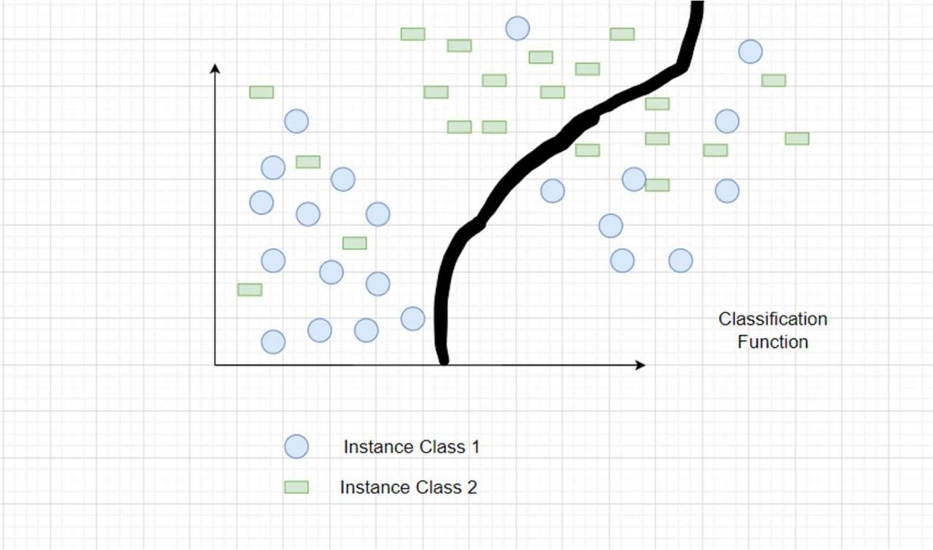
Figure 3.2.5.1 Classification

- •Regression:
It is a supervised learning technique that makes it possible to determine the correlation between variables and predict the continuous output variable based only on the most basic or significant predictor variables. Prediction, forecasting, time collection modeling, and determining the causal-impact relationship between variables are among its specific uses. Regression involves creating a graph with the variables that best fits the provided data points; by using this plot, the machine learning version of the data can be predicted.
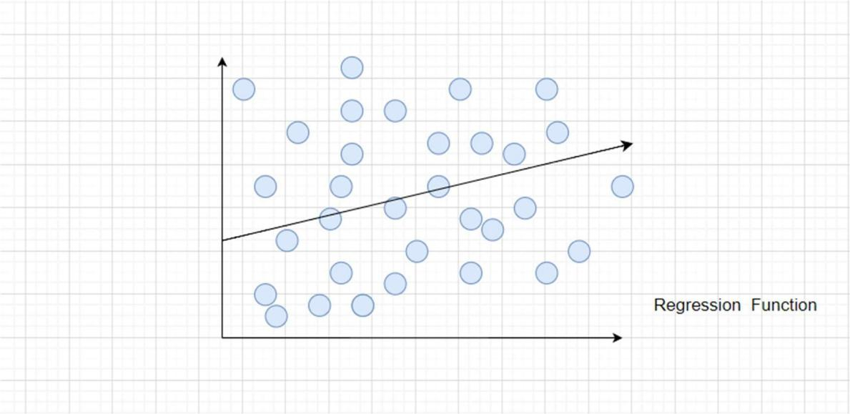

Figure 3.2.5.2 Regression

The Python framework, Flask, was used in the project and numerous libraries were imported for various uses. Eight algorithms were selected: Random Forest, Decision Tree, SVM, Gradient Boost, Naive Bayes, K-Nearest Neighbor, Logistic Regression and Multi-layer Perceptron. Thus, this contains a variety of URL types, including phishing, benign, and spam URLs. The dataset was outsourced from Kaggle which consists of 11,054 rows and 32 columns.
Various machine learning algorithms were examined for analyzing the characteristics in order to gain a thorough understanding of how the URLs that propagate phishing are constructed. For this project, the supervised machine learning techniques and deep learning techniques that we have selected are:
- •Random Forest:
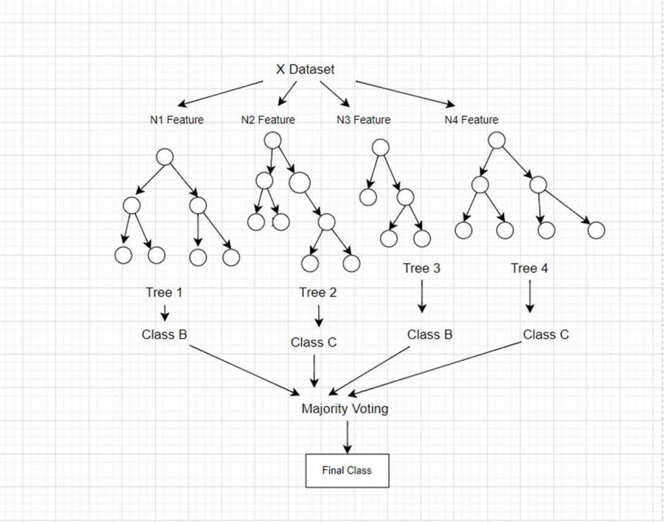
Many random decision trees make up a random forest. The trees contain two different kinds of randomness. Every tree is initially constructed using a random sample of the initial data. Secondly, to produce the best split, a subset of features is randomly chosen at each node in the tree. More trees will prevent the model's trees from being overly fitted. The majority of the data will remain accurate while the missing values are handled by the random forest classifier.

Figure 3.2.5.3 Random Forest

- •Decision Tree:
A random forest is made up of several random decision trees. There are two distinct types of randomness in trees. Each tree is first built with a random subset of the original data. Second, at each node in the tree, a subset of features is randomly selected in order to generate the best split. The model's trees won't be unduly fitted with more trees. While the random forest classifier fills in the missing values, the majority of the data will continue to be accurate.
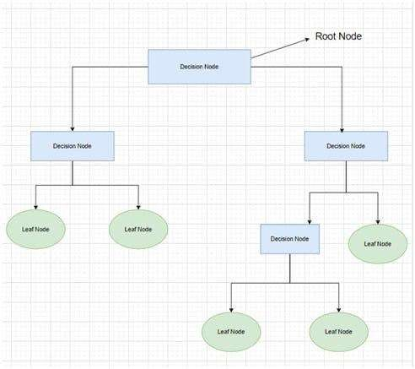

Figure 3.2.5.4 Decision Tree

- •SVM (Support Vector Machine):
Support vector machines (SVMs) are supervised machine learning algorithms that are versatile and strong, and they are utilized for both regression and classification. However, they are typically applied to classification issues. In essence, a hyper-plane in multidimensional space, the Support Vector Machine (SVM) model represents different classes. To reduce the error, the SVM will create the hyper-plane repeatedly. SVM seeks to determine a maximum marginal hyper-plane (MMH) by classifying the datasets.
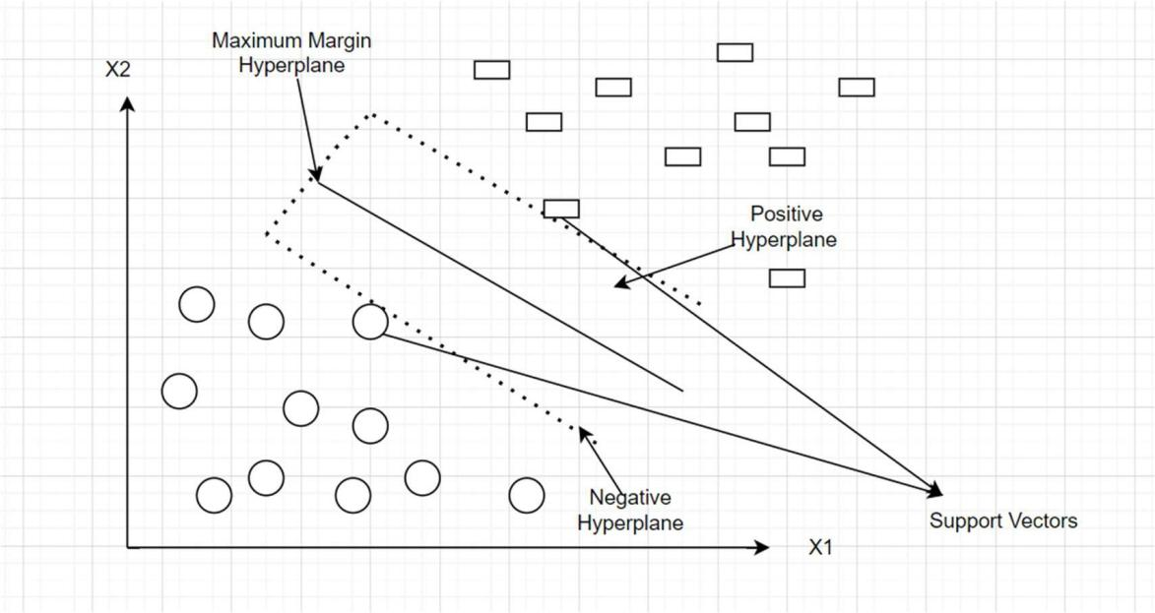

Figure 3.2.5.5 Support Vector Machine

- •Gradient Boost:
Under the Gradient Boosting framework, XGBoost is an open-source software library that implements optimized distributed gradient boosting machine learning algorithms. Gaining a thorough understanding of the machine learning principles and techniques that supervised machine learning, decision trees, ensemble learning, and gradient boosting are based on is essential to comprehending XGBoost. XGBoost is the ideal fusion of hardware and software capabilities created to optimize current boosting methods with maximum speed and accuracy. It is, in general, this algorithm's feasibility, accuracy, and efficiency. It contains algorithms for both tree learning and linear model solving. Therefore, its ability to perform parallel computation on a single machine is what gives it its speed.

- •Flask:
A lightweight Python web framework called Flask was created to make creating web apps and APIs easier. The WSGI (Web Server Gateway Interface) standard is adhered to, and it offers a simple and uncomplicated method for developing websites. Fundamentally, Flask helps developers create web applications by providing necessary tools and conventions, freeing them up to concentrate on writing application logic instead of managing the intricate details of handling HTTP requests and responses. The framework is a well-liked option for projects ranging from small prototypes to larger-scale applications because of its simplicity, adaptability, and ease of use. Because Flask has a modular architecture, developers can easily add more features by integrating different extensions for things like form handling, database interaction, and authentication.

- •Naive Bayes:
"Naive Bayes classifiers" refers to the class of classification algorithms that use Bayes' Theorem as its foundation. Rather than being a single algorithm, it is actually a family of algorithms built on the same principle: every pair of characteristics that is being classed stands alone. It is based on the Bayes theorem. Based on the probability of a previous occurrence, the Bayes Theorem determines the likelihood of a current event. Naive Bayes classifiers are straightforward probabilistic frameworks in statistics that apply the Bayes theorem. The likelihood of a hypothesis given the available information and some prior knowledge forms the basis of this theorem. Given that each feature in the input data is assumed to be independent of every other feature, the naïve Bayes classifier often assumes that false in real-world situations. Despite this oversimplifying assumption of an extra incident that has already happened, the naive Bayes classifier is still widely utilized due to its effectiveness and high performance in several real-world applications.

- •Multilayer Perceptron:
An MLP comprises an input layer, one or more hidden layers, and a layer for output. It is a specific type of feed forward artificial neural network. All of the layers are completely interconnected. An essential idea in deep learning and neural networks will be covered in this article: the Multiple-layer Perceptron Neural Network. The only direction in which the Multilayer Perceptron (MLP) Neural Network may operate is forward. Every node is completely linked to the network. Every node only transmits its value in a forward way to the subsequent node. Backward propagation is an algorithm used by the MLP neural network to improve training model accuracy.
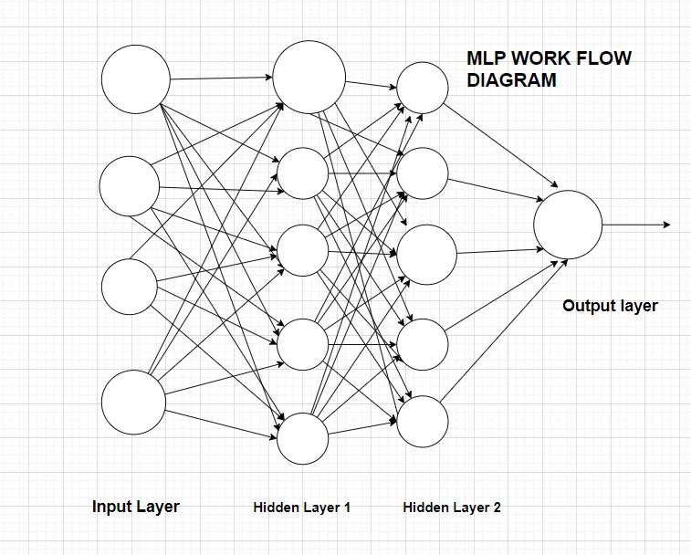

Figure 3.2.5.6 Multilayer Perceptron

- •Logistic Regression:
Logistic regression (LR) is a supervised machine learning technique used to assess the likelihood of an event, a result, or an observation to resolve binary classification problems. The model's output is usually binary, meaning it can be either true or false. Logistic regression is a technique used to sort data according to the degree of correlation between one or more independent variables. It is frequently used in predictive modeling, in which an event's mathematical likelihood of falling into a particular category or not is determined by the model. In binary classification problems, where the outcome variable indicates one of the two categories (0 or 1), logistic regression is frequently utilized. The sigmoid function, a logistic function, is used to map predictions in logistic regression. In addition, if the estimated probability generated by the sigmoid function over a predefined threshold on the graph, the model predicts that the instance belongs to that class. The model states that if the computed probability is less than the preset threshold, the instance does not belong in the class.

- •K-nearest neighbor:
A supervised, non-parametric learning technique is the k-nearest neighbors algorithm (KNN). A data point's classification or grouping is predicted according to how close it is to nearby points. KNN is a flexible technique that is frequently used in machine learning for a range of regression and classification applications. KNN is an acronym for K-Nearest Neighbor. It's an algorithm for supervised machine learning. Problem assertions involving regression and classification can both be resolved by the algorithm. The sign "K" indicates the number of closest neighbors to a new unknown variable that has to be classed or forecasted. KNN determines the separation between every point in the vicinity of the unknown data and eliminates those that have the shortest distances to it.
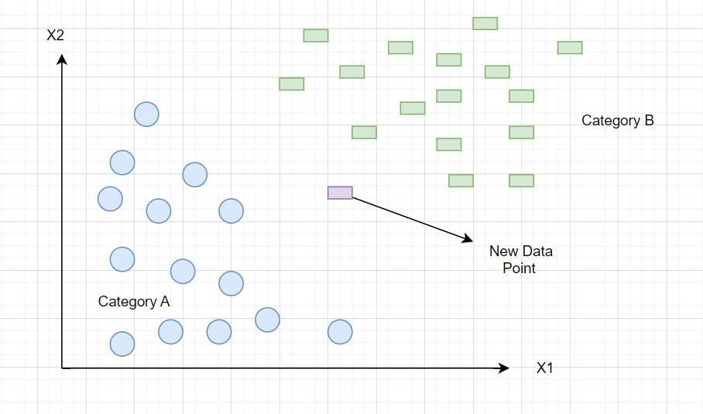

Figure 3.2.5.7 K-Nearest Neighbor

3.2.6 Algorithmic Design of the Proposed System
This project focused on using machine learning techniques for link classification (good or bad), by implementing Flask, a Python framework, and incorporated algorithms like Random Forest, Decision Tree, KNN, Naive Bayes, Logistic Regression, Multilayer Perceptron and Gradient Boost. The classification report, featuring metrics such as recall and precision, evaluates the models' performance. My approach ensures accurate and reliable link classification by leveraging diverse algorithms and thorough performance analysis. Alternatively, the collection of phishing URLs is simple because of the open source supplier known as Phish Tank. This supplier offers a set of phishing URLs that are updated hourly and come in a few different formats, including CSV and JSON. The dataset is immediately loaded into a Data Frame upon download.
A comprehensive feature extraction process was undertaken to analyze the dataset. The features were categorized into distinct groups: Address Bar Based Features, Domain Based Features, and HTML and JavaScript Based Features. The dataset included multiple features designed to evaluate the features of URLs for possible phishing activity. These features include the use of an IP address, the length of the URL, the presence of shortened URLs, symbols like '@' in the URL, double slashes in redirection, prefixes or suffixes in the URL, the number of subdomains, the use of HTTPS, the duration since domain registration, the presence of a favicon, the use of non-standard ports, the presence of HTTPS in the domain part of the URL, request and anchor URLs, links in script tags, type of server form handler, the presence of email addresses, indication of abnormal URLs, website forwarding, customization of the status bar, right-click disable feature, usage of popup windows and iframe redirection, and the age of the domain. The information includes the domain name system recording state, the anticipated traffic to the website, the page rank, the Google indexing status, the number of links referring to the page, the availability of a statistics report, and the label designating whether or not the URL is considered phishing. This dataset offers an extensive range of features for phishing threat analysis and URL classification. The combination of these three feature sets resulted in a comprehensive dataset comprising 32 features, providing a multifaceted perspective for our machine learning models to discern and classify URLs effectively based on their diverse attributes and characteristics.
The goal of this methodical feature combination and selection process was to improve the model's robustness and accuracy in identifying phishing and genuine URLs. Machine learning algorithms were used to classify URLs after finishing feature extraction and merging datasets, and in the end, it was discovered that Gradient Boost produced the best accuracy out of all the algorithms under consideration. The trained Gradient Boost model was then stored for later use. Then, a Flask application with two HTML pages, index.html and result.html, was developed to create an easy-to-use user interface.
Users can enter URLs for classification using the index.html page, which also acts as an input interface. The results of the classification are shown on the result.html page. The Flask application, defined in the app.py file, was tested in development mode on my local machine, providing a practical platform for users to interact with the trained Gradient Boost model in real-world scenarios. This cohesive solution, integrating the robust Gradient Boost model with the Flask web application, offers a user-friendly tool for users to assess and categorize URLs based on the machine learning model's predictions.
Eight different algorithms were thoroughly compared, with an emphasis on how accurately they could classify URLs. Random Forest, Decision Tree, Multi-layer Perceptron, KNN, Logistic Regression, Support Vector Machine (SVM) and Gradient Boost, were the algorithms that were being examined. Following the training and assessment of every model, it was discovered that Gradient Boost performed better than the others, obtaining an astounding accuracy score of 97.4%. The comparison process involved training each algorithm on labeled datasets, assessing their performance, and selecting the model with the highest accuracy for further deployment. Gradient Boost, with its ensemble learning approach and gradient boosting techniques, demonstrated superior predictive power in distinguishing between different types of URLs, showcasing its effectiveness in our specific use case. The choice of Gradient Boost as the optimal model underscores its ability to handle complex relationships within the data, providing a robust solution for URL classification in our project. This high accuracy score serves as a testament to the efficacy of Gradient Boost in addressing the challenges posed by diverse URL characteristics and categories.

3.2.7 System Analysis Flow Chart
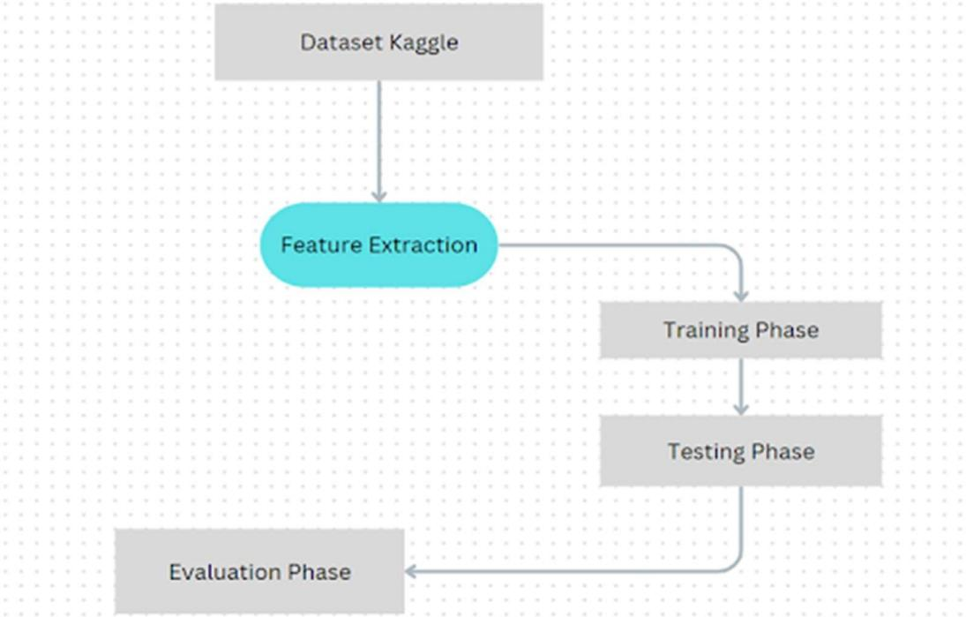

Figure 3.2.7.1 Flow Chart

I have been able to predict whether websites are good (legitimate) or bad (phishing) via URLs in this project. Datasets were searched online and discovered before running any code, which led to the development of code snippets needed to extract the feature after gathering the phishing and estimated websites from open source platforms. There are various kinds of URLs, including malicious, phishing, spam, and benign URLs. Owing to that fact, I decided to take the dataset from Kaggle. The datasets have been reviewed, pre-processed, and separated into training and test sets. I employed the enlisted machine learning algorithms and deep learning algorithm to categorize URLs, ultimately finding that Gradient Boost yielded the highest accuracy among the algorithms considered. Subsequently, the trained Gradient Boost model was saved for future use. To create an intuitive user interface,a Flask application was developed with two HTML pages: index.html and result.html. Flask application, defined in the app.py file, was executed on the local system, providing a practical platform for users to interact with the trained model.
Numerous training implementations for this project and the prediction of the legitimacy of phishing websites were carried out and tested. Some of the supervised algorithms with deep learning algorithms have been used. An overview of the process is described below:
- •Firstly, some libraries such as pandas, numpy, and matplotlib were imported, as well as Decision Tree Classifier and many more.
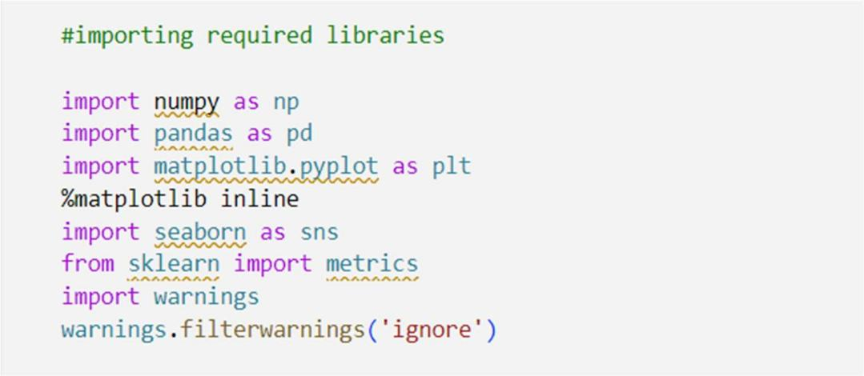

Figure 3.2.7.2 Imported Libraries

- •Analyzing the dataset from Kaggle consisting of 32 features.

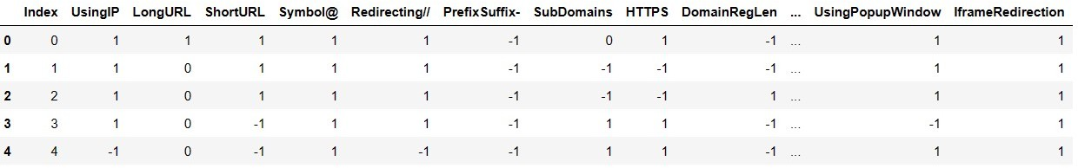
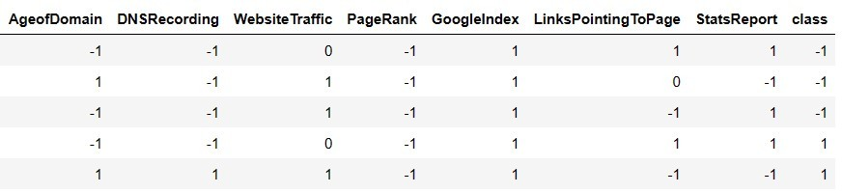
Figure 3.2.7.3 Dataset Features

- •Feature Extraction Process
- •Using IP

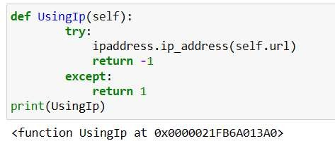
Figure 3.2.7.4 IP Address
- •Long URL
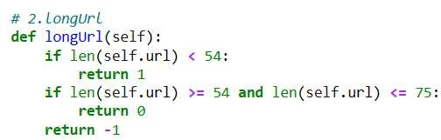

Figure 3.2.7.5 Long URL Extraction
- Short URL

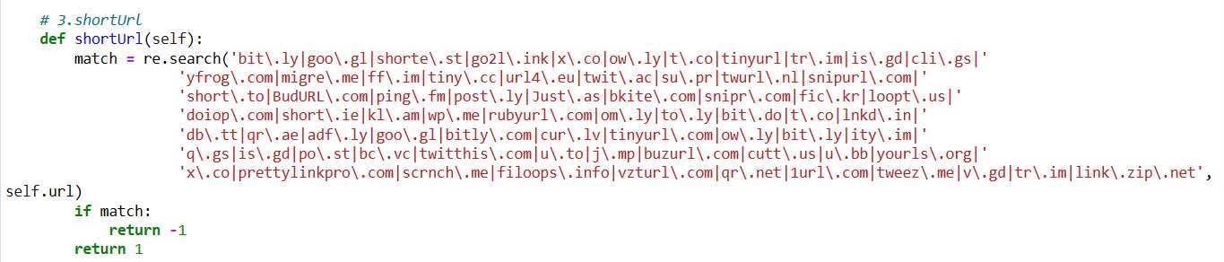
Figure 3.2.7.6 Short URL Extraction

- •Symbol@

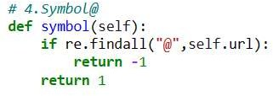
Figure 3.2.7.7 @Symbol Extraction
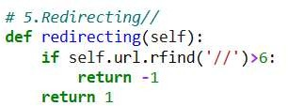
- •Redirection “//” in URL

Figure 3.2.7.8 Redirection of (//) Symbol
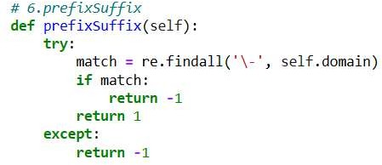
- •Prefix Suffix

Figure 3.2.7.9 Prefix and Suffix Extraction
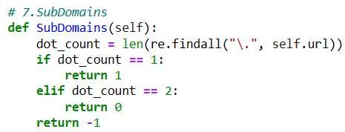
- •Sub Domains

Figure 3.2.7.10 Sub Domains
- •HTTPS
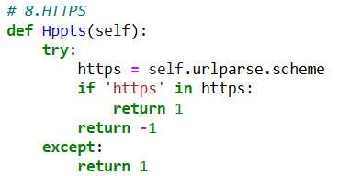

Figure 3.2.7.11 Extraction of HTTPS
- •Domain Length

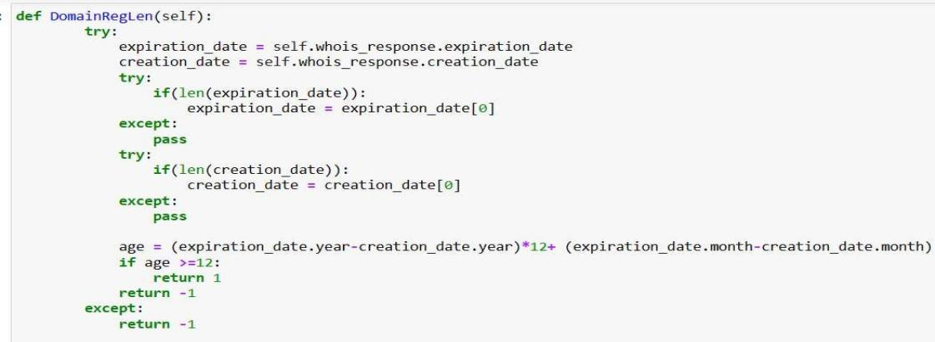
Figure 3.2.7.12 Domain Length
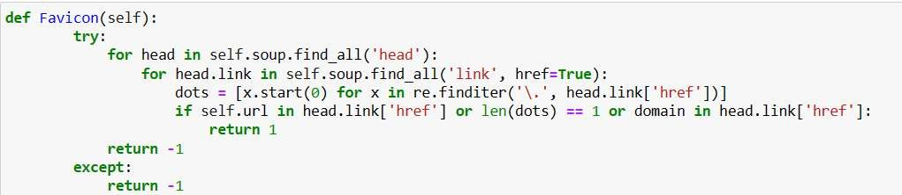
- •Favicon

Figure 3.2.7.13 Favicon
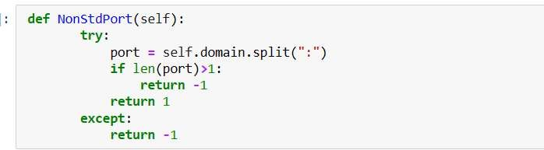
- •NontdPort

Figure 3.2.7.14 Std Port Extraction

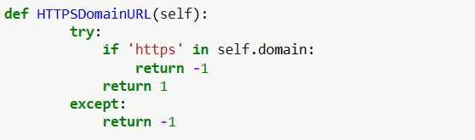
- •HTTPS Domain URL

Figure 3.2.7.15 Domain URL Extraction
- •Request URL
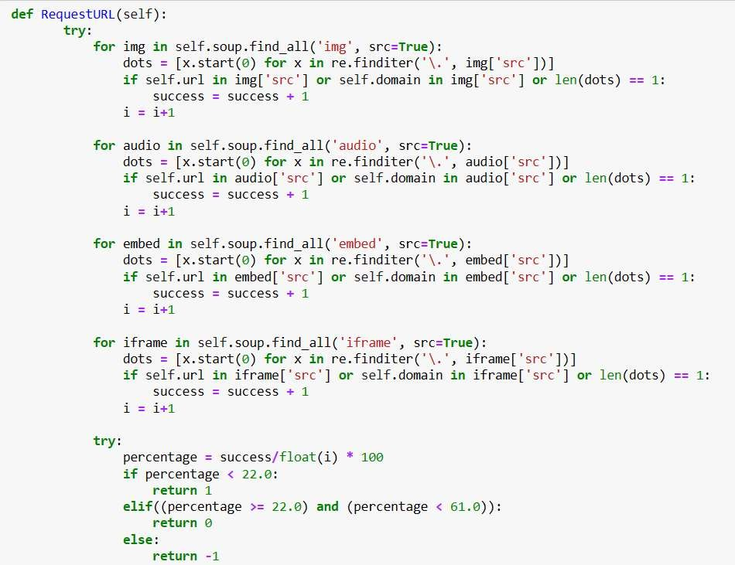

Figure 3.2.7.16 Request URL

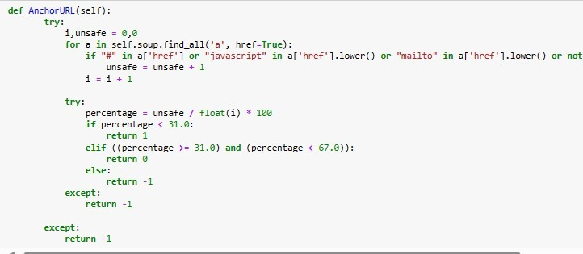
- •Anchor URL

Figure 3.2.7.17 Anchor URL Extraction
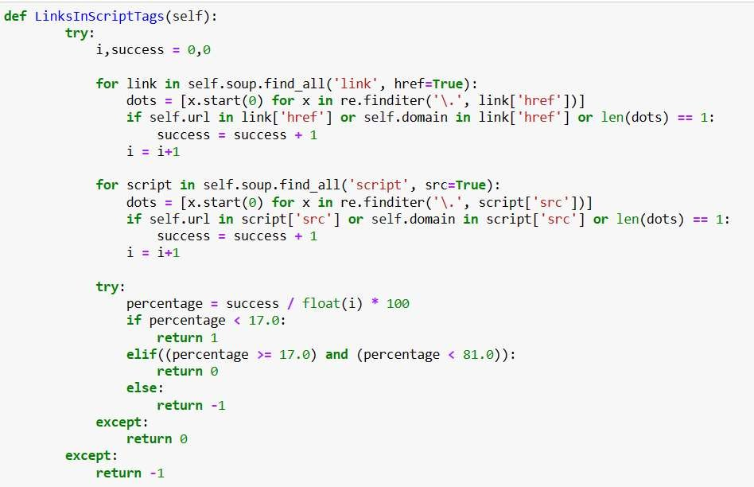
- •Script Tags

Figure 3.2.7.18 Script Link Tags

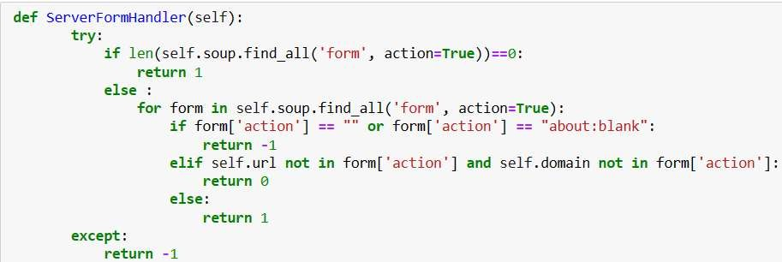
- •Server Handler

Figure 3.2.7.19 Server Handler Captioning
- •Email Info
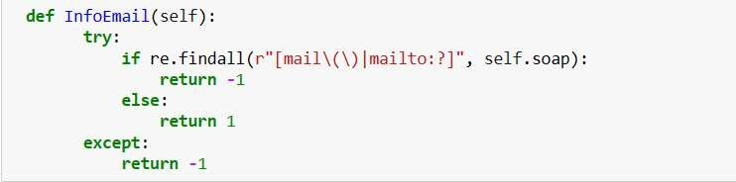

Figure 3.2.7.20 Email Information
•
- Abnormal URL

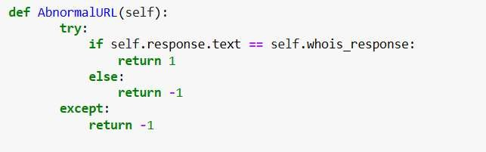
Figure 3.2.7.21 Abnormal URL Extraction
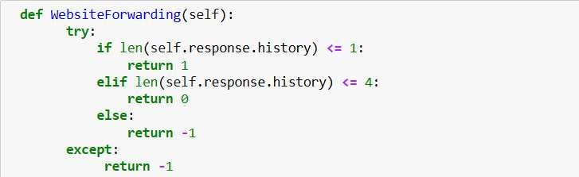
- •Website Forwarding

Figure 3.2.7.22 Website Forwarding Response
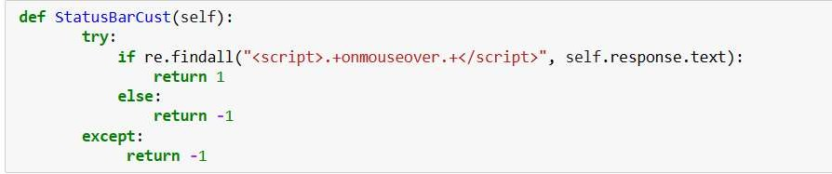
- •Status

Figure 3.2.7.23 Status Bar Finder
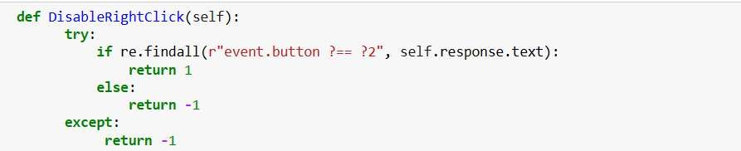
- •Disable Right Click

Figure 3.2.7.24 Disable Right Click

- •Using Popup Window
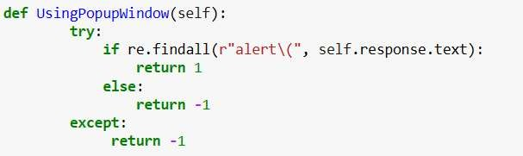

Figure 3.2.7.25 Popping Window
- •Iframe Redirection
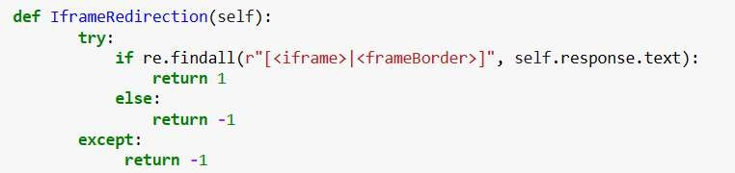

Figure 3.2.7.26 Redirection of Iframe
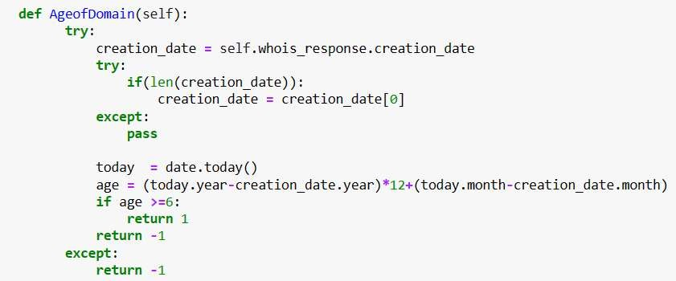
- •Age of Domain

Figure 3.2.7.27 Age Domain Handler

- •DNS Recording

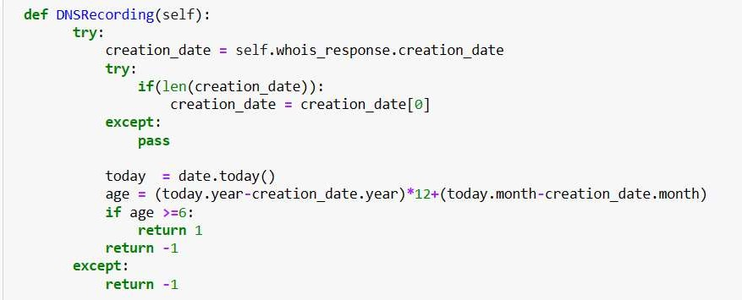
Figure 3.2.7.28 DNS Recording Handler
- •Page Rank
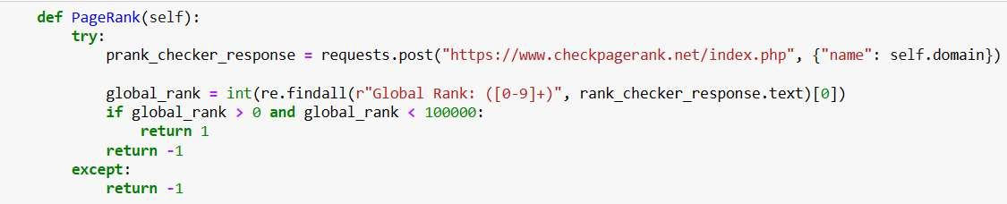

Figure 3.2.7.29 Page Rank Response Checker
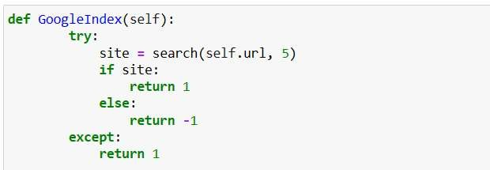
- •Google Index

Figure 3.2.7.30 Google Index Handler

- •Links Pointing To Page
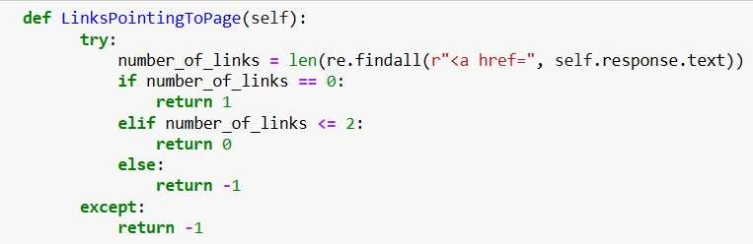

Figure 3.2.7.31 Number of Links Pointing
- •Stats Report

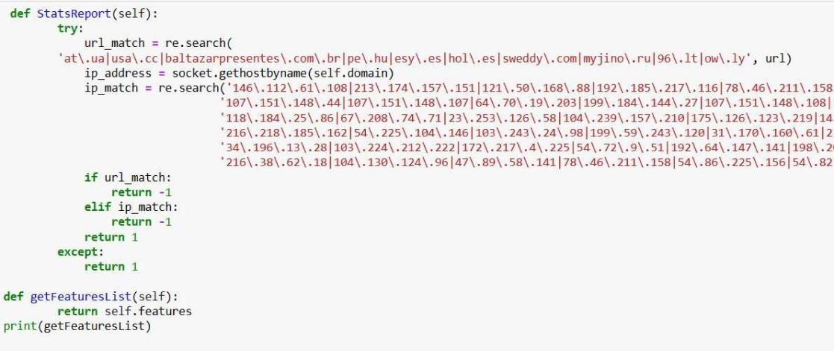
Figure 3.2.7.32 Matching Stats Report

3.3 System Design Methodology
System design methodology refers to the structured framework adopted to develop, train, test, and implement the phishing website detection model.
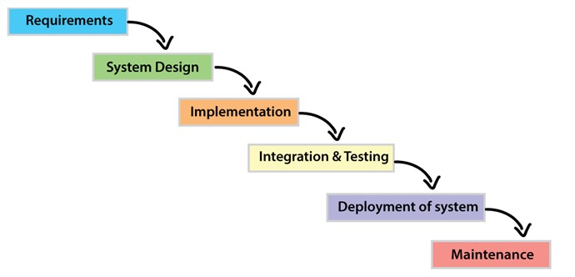
The Waterfall model was used as the software development methodology. The Waterfall model is a traditional, linear SDLC approach where each phase is completed before the next begins. In our context, this means we will proceed sequentially through: requirements analysis, system design, implementation, testing, deployment, and maintenance. The waterfall model involves a sequential approach to software development, where each phase is completed before moving on to the next one. This structured approach fits the project because the requirements (a phishing-check web app) are relatively well-defined upfront, allowing thorough specification before coding.
Under Waterfall, a detailed documentation is produced at each stage. For example, a Software Requirements Specification (SRS) is generated that clearly lists all system requirements. Then design documents (high-level and low-level designs) will be created before any coding begins. After implementation, rigorous integration and system testing will be conducted before final deployment. The advantages of this model include clear milestones, easy progress tracking, and comprehensive documentation (SRS, design docs) to guide development and future maintenance.

3.3.1 Requirement Specification
The first major deliverable is the Requirements Specification. All functional and non-functional needs will be compiled into a Software Requirements Specification (SRS) document. This SRS serves as a contract and guide: it captures what the system must do and how it should perform. As noted in the Waterfall tutorial, “These analyzed requirements are documented in a software requirement specification (SRS) document. SRS document serves as a contract between the development team and customers”. The SRS will help ensure that developers and stakeholders have a shared understanding of scope. The SRS will include descriptions of every use case and system feature (functional requirements), plus performance, security, and environmental constraints (non-functional requirements).

3.3.2 Functional Requirement Specification
Functional requirements describe the specific features and operations the system must provide. According to software engineering references, “the Functional Requirement Specification (FRS) outlines all the functions the software or product must perform”. In this case, key functional requirements might include:
- •User Authentication and Access Control: The current system is a Free-For-All. It doesn’t provide an optional authentication system with session management. The system shall allow users to submit or input a website URL for analysis.
- •Data Collection and Entry: The system shall accept a URL input from the user and analyze it using the ML model. The system shall extract relevant features from the URL and web page content( e.g. domain properties, HTML patterns, external links). This information helps the model make predictions.
- •Data Preprocessing: Before using the data, the system should clean and prepare it. This includes fixing missing values, removing errors, and converting text into numbers the model can understand.
- •Model Training and Updating: The system must allow training the predictive model using historical data. It should also support retraining when new data becomes available to improve accuracy and return a clear result (e.g. “Phishing” or “Legitimate”) for each submitted URL.
- •Risk Prediction: After training, the system should predict possible risks from new data. It should sort URLs into risk levels (malicious, phishing, spam, benign) and suggest possible recommendations and display the analysis outcome and any relevant information (such as confidence score or reasons) to the user.
- •Activity Logging and Audit Trail: All key actions (e.g., login, data changes, model updates) must be recorded. This helps in tracking activities and fixing issues when needed.
- •Admin Controls (if applicable): Authorized administrators may upload new phishing data or retrain the model to improve accuracy. The system shall provide administrative functions (for an admin user) to update the underlying dataset, retrain the model, and manage system configurations.
- •Data Storage and Retrieval: URL data and prediction results should be saved safely in a database. The system should allow users to easily find and review past records.

3.3.3 Non-Functional Requirement Specification
Non-functional requirements (NFRs) define how the system performs its tasks—its quality attributes. They include constraints like performance, reliability, usability, security, etc. As one source summarizes, non-functional requirements focus on attributes such as “performance, security, scalability, and usability” (whereas functional requirements describe what the system does). For this web-based phishing detector, the important NFRs include:
- •Performance: The system should respond quickly. For instance, each URL submission should be processed and a result returned in under 10 seconds.
- •Availability/Reliability: The web service should be highly available (e.g. >99% uptime) and handle concurrent users without crashing.
- •Usability: The web interface must be user-friendly and clear, so that non-technical users can easily enter URLs and understand results.
- •Security: The system must protect user data and prevent unauthorized access. For example, communications in transit should use HTTPS, and user credentials must be stored securely.
- •Scalability: The architecture should allow horizontal scaling (e.g. on cloud servers) to accommodate growth in usage.
- •Maintainability: The codebase and design should be version-controlled (GitHub), modular and well-documented so that future developers can update or extend the system easily.
- •Portability: The system should run on standard web platforms (it will be based on Flask/Python and standard web frameworks).
- •Deployment: The system will be built with the Flask web framework, hosted on a platform like Render, and integrated with continuous deployment from the GitHub repository. This ensures the system is web-based and easily accessible to users.

3.4 System Design

3.4.1 Use Case Diagram
The primary actors are the User and an Administrator. The User can submit a URL for analysis. After submitting the URL, the system (Phishing Detector) extracts features and classifies the URL using the trained model. The User then receives the result (phishing or safe). The Administrator actor is responsible for managing the ML model (e.g. uploading a new Random Forest model version or retraining) and monitoring system status. These interactions are represented in the use case diagram.
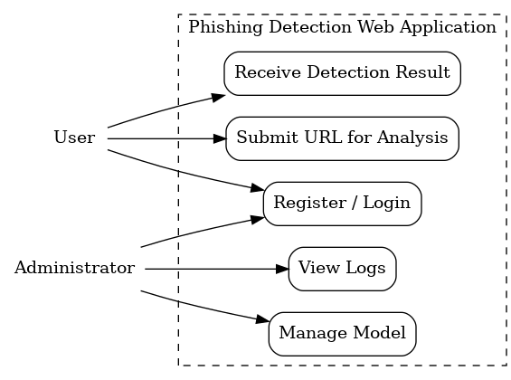

Figure 3.4.1 Use Case Diagram

3.4.2 Activity Diagram
The activity diagram models the workflow from user input to classification. It describe the steps as follows: first, the User logs in or registers if necessary, then enters a URL. The system retrieves the saved model and extracts features from the URL. Next, the features are fed into the machine learning classifier, which produces a prediction. Finally, the system displays the result to the user and the activity ends. In essence, it is a flowchart of actions and decisions.
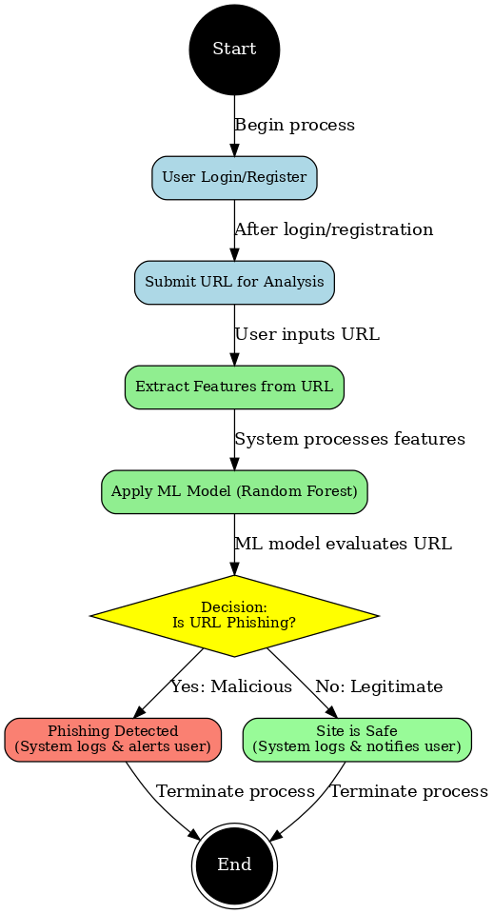

Figure 3.4.2 Activity Diagram

3.4.3 Class Diagram
A UML class diagram identifies the system’s main classes, attributes, methods, and relationships. In general, class diagrams “describe the structure of a system by showing classes, their attributes, operations (or methods), and the relationships among objects”.
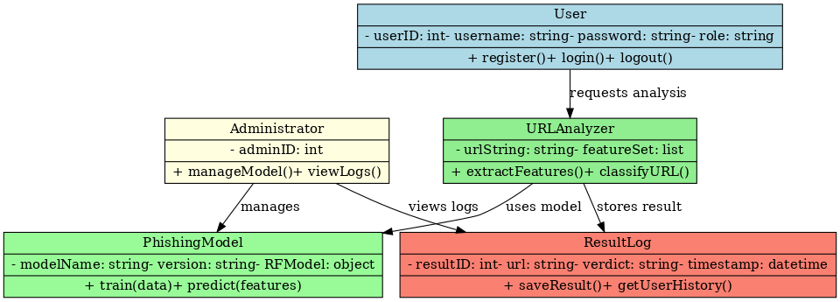

Figure 3.4.3 Class Diagram

3.4.4 Data-Flow Process of the System
Data Flow Diagram (Context/Level-0)
The Level-0 DFD shows how external entities interact with the system and how data moves through it. Here the main external entities are the User and the Administrator. The core process is Phishing URL Analysis. Key data stores include the Model Store (holding the trained Random Forest model and possibly feature extractors) and a User/Result Database. Data flows include:
- •User → (Process) Phishing URL Analysis: The user sends input data (login credentials and URL to check).
- •(Process) → Model Store: The system reads the model (trained Random Forest) from storage.
- •(Process) → (Process) Internal: Within the process, the URL is checked. (Feature extraction and classification occur internally.)
- •(Process) → User: The system returns the classification result (e.g. “phishing” or “safe”) as output.
- •Admin → (Process): An administrator can update the Model Store (via model upload or retraining).

Figure 3.4.4 Data-Flow Process

3.5 Summary
In this chapter, a thorough analysis of both existing anti-phishing approaches and the proposed solution was conducted. It was discovered that traditional methods (blacklists and fixed heuristics) are limited by their inability to adapt to new threats. To address this, the proposed system uses machine learning and a modern web framework, enabling real-time classification of any URL via a Flask-based interface. An adoption of the Waterfall model was made to systematically develop the system: first gathering and specifying requirements (functional and non-functional), then designing and implementing the solution, and finally planning rigorous testing and deployment. All requirements have been documented in an SRS, and the system architecture has been captured using UML diagrams (use-case, activity, class) and a data-flow diagram. Finally, an outline was drafted for a cloud-based deployment plan (GitHub + Render) to make the application accessible online. The next chapter will describe the implementation and testing of this design.

